Experiment List for Programming Ability and Logic Building-1
Name : Yashi Jaiswal
Batch : 2CSE5
Roll Number : 25scs1003004069
Week : 19/1/26 to 25/1/26
Lecture : 1

EXPERIMENT 1
You are given an array of integers arr[]. You have to reverse the given array. Note: Modify the array in place.
Examples:
Input: arr = [1, 4, 3, 2, 6, 5]. Output: [5, 6, 2, 3, 4, 1]
Explanation: The elements of the array are [1, 4, 3, 2, 6, 5]. After reversing the array, the first element goes to the last position, the second element goes to the second last position and so on. Hence, the answer is [5, 6, 2, 3, 4, 1].

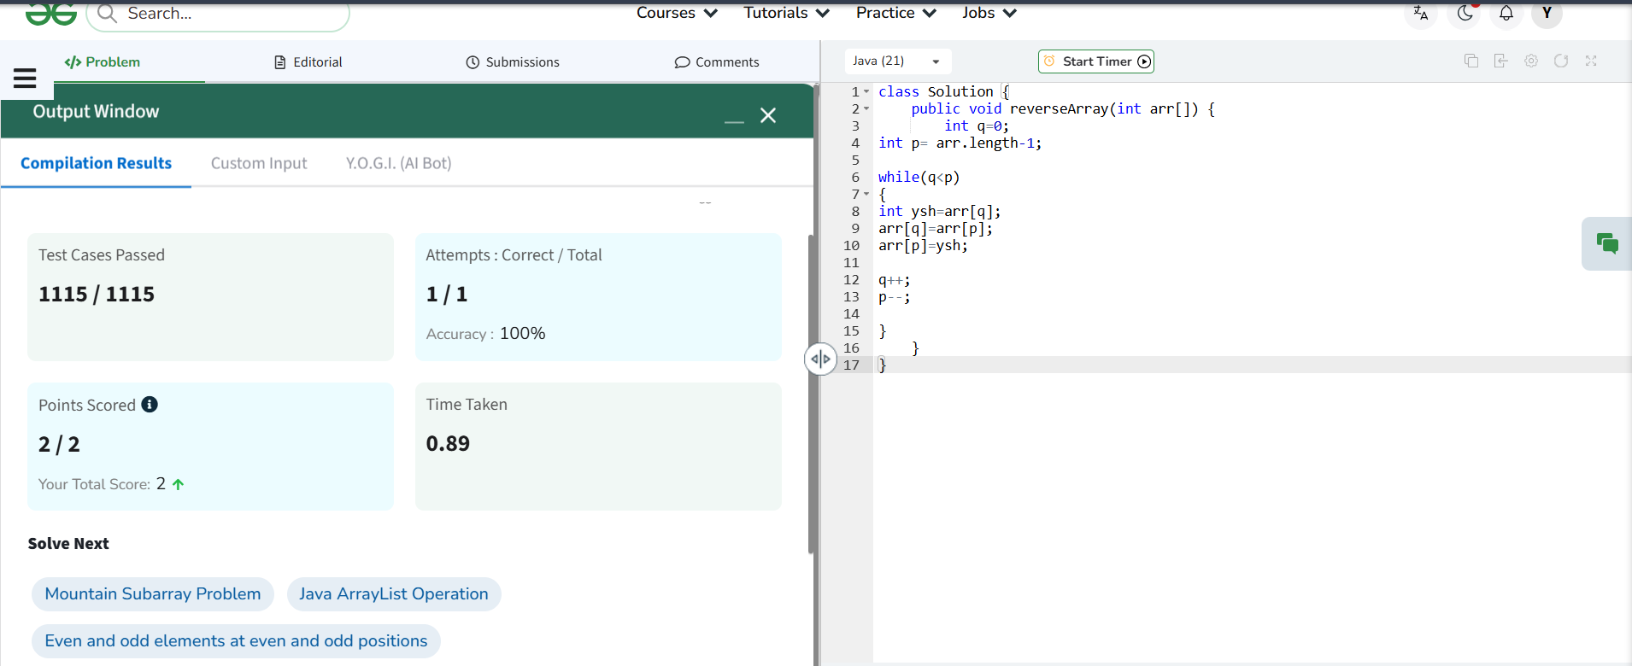

EXPERIMENT 2
Given an array arr[]. Your task is to find the minimum and maximum elements in the array.
Examples:
Input: arr[] = [1, 4, 3, 5, 8, 6]. Output: [1, 8]
Explanation: minimum and maximum elements of array are 1 and 8
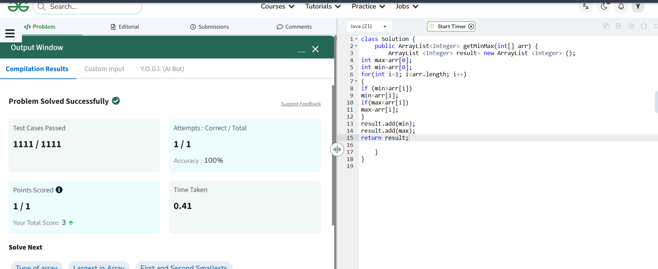

EXPERIMENT 3
Given an integer array arr[] and an integer k, your task is to find and return the k th smallest element in the given array.
Note: The kth smallest element is determined based on the sorted order of the array.
Examples :
Input: arr[] = [10, 5, 4, 3, 48, 6, 2, 33, 53, 10], k = 4 Output: 5
Explanation: 4th smallest element in the given array is 5
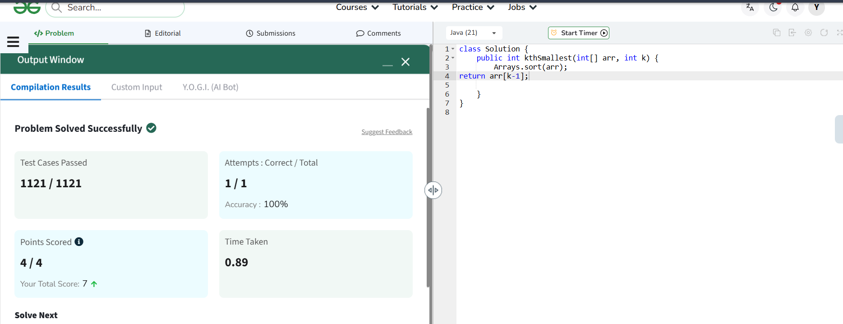

EXPERIMENT 5
Given an array arr[]. The task is to find the largest element and return it.
Examples: Input: arr[] = [1, 8, 7, 56, 90]. Output: 90
Explanation: The largest element of the given array is 90
